**Name:**

**Advanced Programming in Java**

**Lab Exercise 1.8.2025**

**The Discount System**

You are asked to write a discount system for a beauty salon, which provides services and sells beauty products. It offers 3 types of memberships: Premium, Gold and Silver. Premium, gold and silver members receive a discount of 20%, 15%, and 10%, respectively, for all services provided. Customers without membership receive no discount. All members receives a flat 10% discount on products purchased (this might change in future). Your system shall consist of three classes: Customer, Discount and Visit, as shown in the class diagram. It shall compute the total bill if a customer purchases $x of products and $y of services, for a visit. Also write a test program to exercise all the classes.

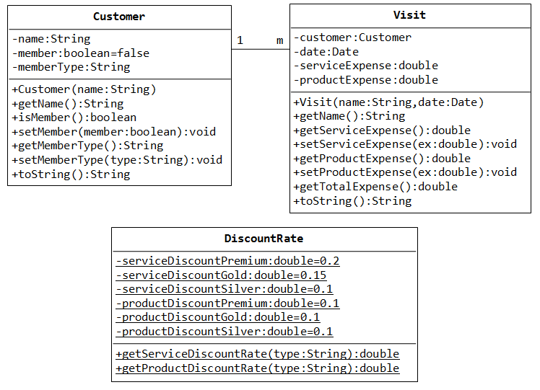

**Convenience Store**

Given a total due and an array representing the amount of change in your pocket, determine whether or not you are able to pay for the item. Change will always be represented in the following order: quarters, dimes, nickels, pennies.

To illustrate: changeEnough([25, 20, 5, 0], 4.25) should yield true, since having 25 quarters, 20 dimes, 5 nickels and 0 pennies gives you 6.25 + 2 + .25 + 0 = 8.50.

**Examples**

changeEnough([2, 100, 0, 0], 14.11) ➞ false

changeEnough([0, 0, 20, 5], 0.75) ➞ true

changeEnough([30, 40, 20, 5], 12.55) ➞ true

changeEnough([10, 0, 0, 50], 3.85) ➞ false

changeEnough([1, 0, 5, 219], 19.99) ➞ false

**Notes**

* **quarter**: 25 cents / $0.25
* **dime**: 10 cents / $0.10
* **nickel**: 5 cents / $0.05
* **penny**: 1 cent / $0.01

**The 3 Programmers Problem**

You hired three programmers, and you (hopefully) pay them. Create a function that takes three numbers (the hourly wages of each programmer) and returns the difference between the highest-paid programmer and the lowest-paid.

**Examples**

programmers(147, 33, 526) ➞ 493

programmers(33, 72, 74) ➞ 41

programmers(1, 5, 9) ➞ 8

**Notes**

* Don't forget to return the result.